**Retail Sales Analysis**

By: Olutola Adunoluwa Toby

**Aim**

The analysis was performed to evaluate the sales performance of the retail company and find opportunities to increase its quarterly earnings. The analysis highlighted the top-performing segments the business should focus on and the underperforming products in terms of orders and revenue generation. The analysis also features sales and revenue forecasting based on historical data to predict future trends.

**Summary**

Furnishings was the best-performing category, with the highest revenue generated ($226.8k) and sales between 2015 and 2016. However, office supplies performed the least, with about $29.6k in revenue. The king-sized and double beds generated the highest revenues across both years. Finally, California, Virginia, and Missouri generated about 26% of the revenue and 20% of all orders, with Missouri having the highest average revenue per order.

**Data Model**

This data model’s Entity Relationship Diagram (ERD) was drawn using the Crow’s Foot Notation. The dataset consisted of three tables or entities uniquely related to each other: order details, products, and property info. The simple ERD was drawn using the following business rules:

An order could contain at least one or more products, but a product could be included in many orders or may not be ordered at all. Likewise, each order can come from one and only one location, i.e., state, but none or many orders could be made from one state.

Figure : Data Model of the Retail Database

**Retail Table Creation**

**Total Revenue, Quantity, Orders, and their Percentage Split per Segment**

**Aggregation by Product Category**

**Result**

Figure : Query result showing revenue, quantity, and orders per product category

Figure : Visualization of revenue and orders per category on Power BI

Figure : Revenue per product category

**Aggregation by State**

**Result**

Figure :Query result showing revenue, quantity, and orders per state

Figure : Revenue generated per state

**Aggregation by Date – Month and Year**

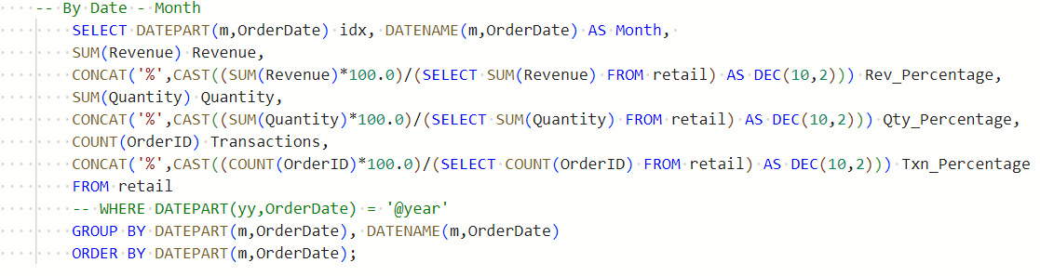

**Result**

Figure : Query result showing revenue, quantity, and orders per month

Figure : Time series analysis of revenue and orders

**Revenue Growth per Year**

**Result**

Figure : Trend analysis of average revenue for the furnishings category

Figure :Trend analysis of average revenue for the housekeeping category

Figure : Trend analysis of average revenue for the maintenance category

Figure : Trend analysis of average revenue for the office supplies category

Figure : Trend analysis of average revenue for the public areas category

**Order Growth per Year**

**Result**

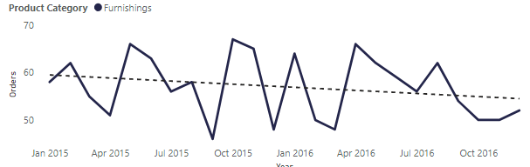

Figure : Trend analysis of orders for the furnishings category

Figure : Trend analysis of orders for the housekeeping category

Figure : Trend analysis of orders for the maintenance category

Figure : Trend analysis of orders for the office supplies category

Figure : Trend analysis of orders for the public areas category

**Top Products per Category**

**Result**

**Average Revenue Per Category**

Figure : Average revenue per category

**Stored Procedures Using Dynamic SQL**

Average Revenue per Segment

Percentage Split for Quantity, Revenue, and Orders per Segment

Retail Dashboard

Retail Dashboard

